Design Decision Making Document

This document highlights important design decision made with selected app features and interface design in our app

|  |  |  |
| --- | --- | --- |
| Index | Content | Page |
| 1 | Initial Ideation Interface | 2 |
| 2 | Final Interface: User End | 9 |
| 3 | Final Interface: CMS | 19 |

**INITIAL IDEATION INTERFACE**

**Centred-Focus Design**

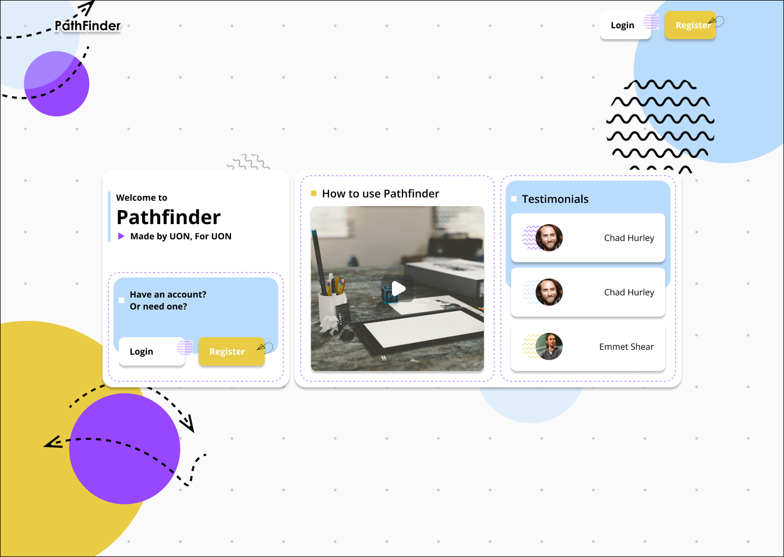

**Colours:**

The colours yellow and light blue were chosen for background of the text and “Register” buttons because they are light and work as a highlighter to draw users to focus on those areas. The mainly white background gives a clean and professional look.

**Layout:**

The top left shows the name/logo of our website.

The top right has the login and register buttons for frequent users to easily access without needing to find the other login and register button in the middle of the page surrounded by more text.

The middle of the page is mainly for new users, which provides a video tutorial on how to use our website, and testimonials to show users why our website will suit their needs. It also has a login and register button.

**Specific UI:**

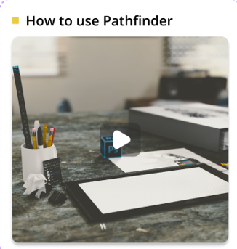

This video tutorial on how to use our website is strategically placed in the center to attract users to focus on it and eventually click play. The size of the video player is the largest in the entire page, to show its importance.

**Side Panel Design 1**

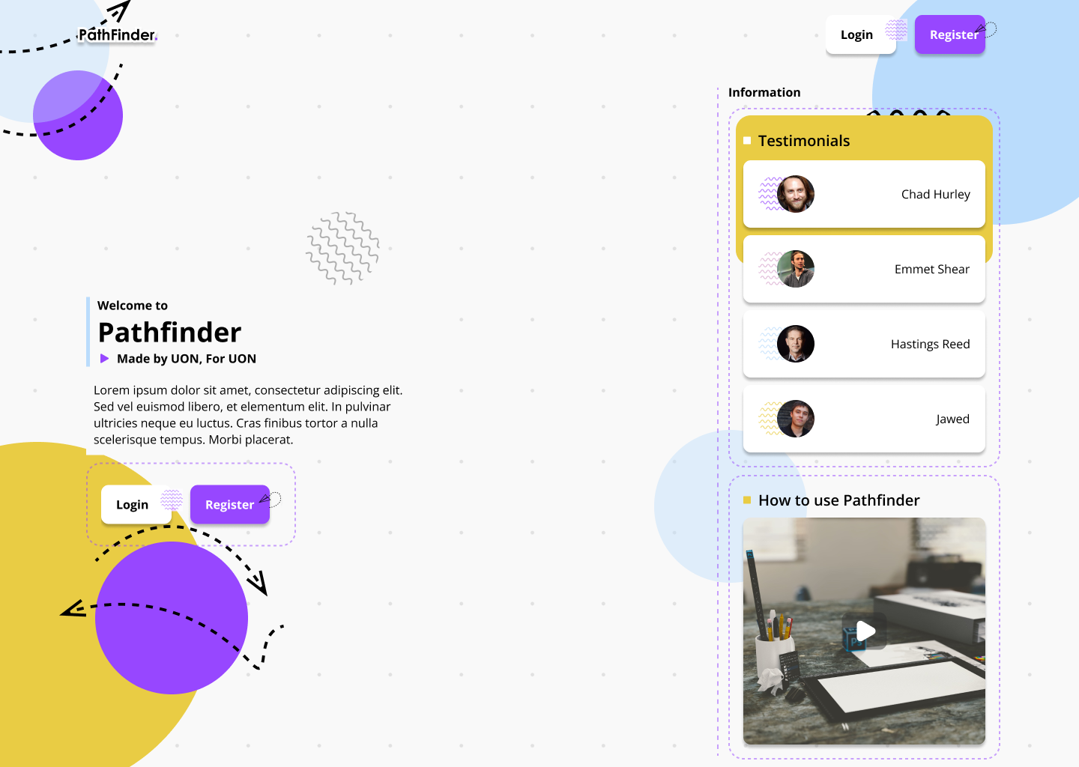

**Colours:**

The colours yellow and light blue were chosen for background design. Purple was chosen for the “Register” buttons because they stand out and work as a highlighter to draw users to focus on those areas. The yellow background behind “Testimonials” also highlight that entire section more. The mainly white background gives a clean and professional look.

**Layout:**

The top left shows the name/logo of our website.

The top right has the login and register buttons for frequent users to easily access without needing to find the other login and register button in the middle of the page surrounded by more text.

The right section of the page is mainly for new users, which provides a video tutorial on how to use our website, and testimonials to show users why our website will suit their needs. Instead of focusing on the video tutorial in the “Centered Focus” design above, this “Side Panel Design 1” focuses more on the the testimonials, as we have made that section the largest section in the entire page, slightly larger than the video tutorial, and positioned above it for more emphasis.

**Side Panel Design 2**

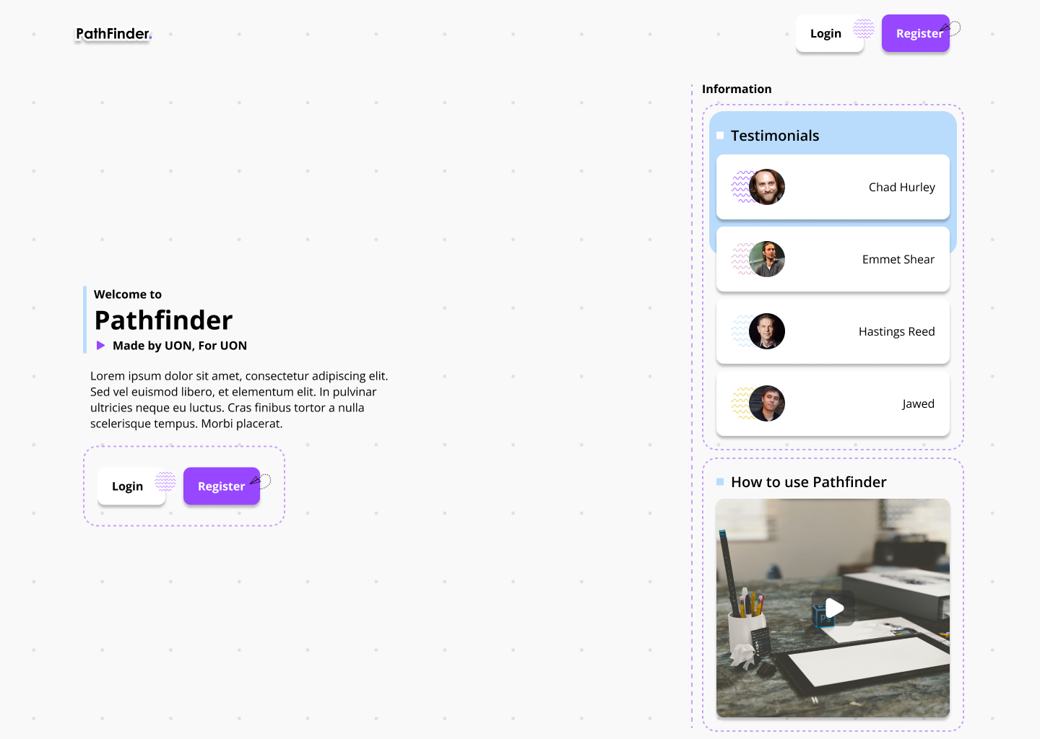

**Colours:**

Purple was chosen for the “Register” buttons because they stand out and work as a highlighter to draw users to focus on those areas. The light blue background behind “Testimonials” also highlight that entire section more. The fully white background gives an extremely clean and professional look.

**Layout:**

The layout for this design is exactly similar to that of “Side Panel Design 1”, with the exclusion of the coloured circle designs in the background. This design is aimed to be as minimalistic as possible.

**Emoji Grid 1**

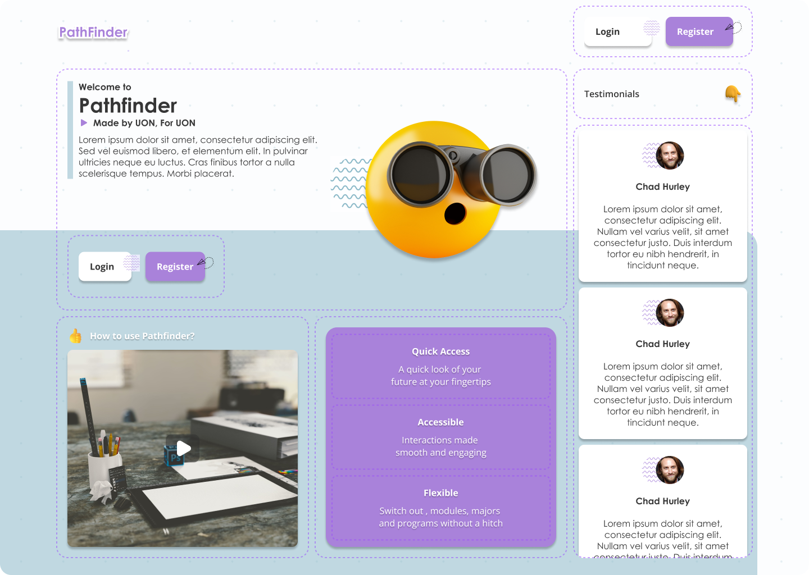

**Colours:**

Purple was chosen for the “Register” buttons because they stand out and work as a highlighter to draw users to focus on those areas. The partially white background gives a clean and professional look, while the light gray bottom half acts as a separation for the “login and register” buttons, “video tutorial”, and “selling points” section. There is also a yellow emoji design in the middle, to give our page a more modern and aesthetic look.

**Layout:**

The top left shows the name/logo of our website.

The top right has the login and register buttons for frequent users to easily access without needing to find the other login and register button in the middle of the page surrounded by more text.

A description of our website is in the middle section nearer to the top, with another set of login and register buttons just below it. The 3 largest sections we have are the video tutorial section, selling points section, and testimonials section. The video tutorial and selling points section are at the bottom left stretching to the middle, and are next to each other with an equal size. The testimonials section are at the right column, stretching from the login and register buttons, all the way to the bottom.

**Specific UI:**

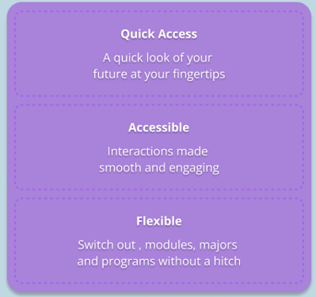

This “selling points” section is aimed at giving showing new users why our website would be ideal for them to use, and also to encourage them to register for our website. That is why the register button is right next to this section.

**Emoji Grid 2**

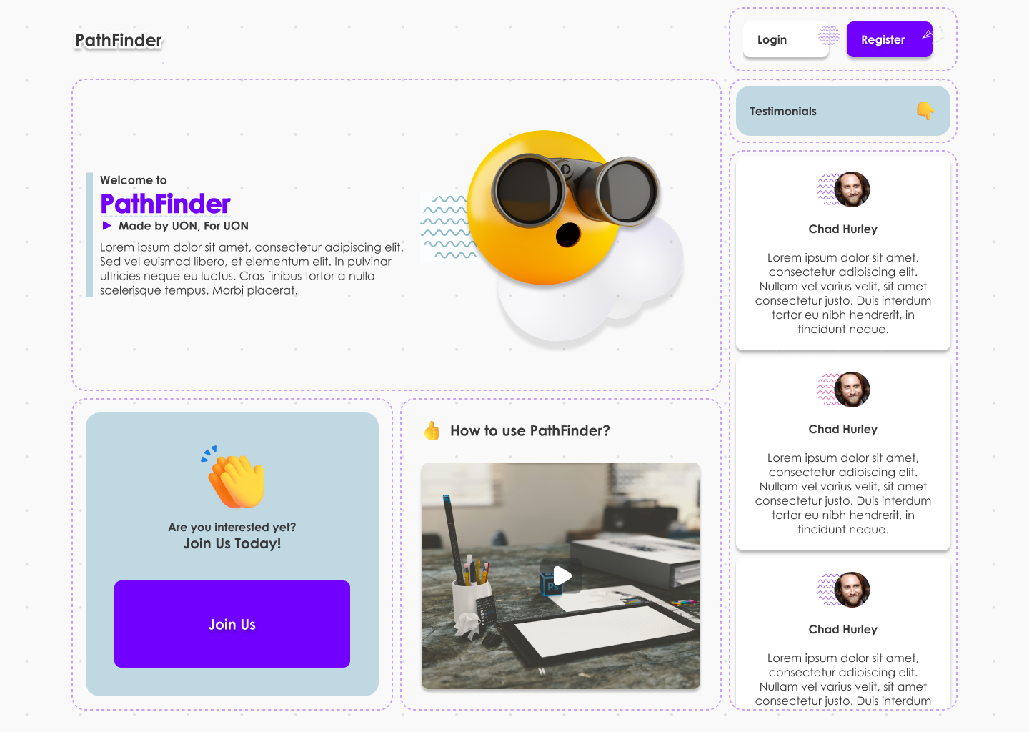

**Colour:**

Blue was chosen for the “Register” and “Join Us” buttons because they stand out and work as a highlighter to draw users to focus on those areas. The white background gives a clean and professional look. There is also a yellow emoji design in the middle, to give our page a more modern and aesthetic look.

**Layout:**

The layout is exactly the same as that of “Emoji Grid 1” design, except that the “video tutorial” section is in the middle, and the “selling points” section is now replaced with a “Join Us” section.

**Buttons:**



This “Join Us” section is aimed at enticing new users to register an account with us, by using a large “Join Us” button, that stands out more than anything else on the page. It is blue in colour, with a yellow clapping emoji above it to make it even more prominent.

**FINAL INTERFACE: USER END**

**Landing Page**



**Background:**

The Landing Page design maintains a clean and modern aesthetic, with a crisp white background. This choice is deliberate, enhancing simplicity and readability, allowing the content to shine as the focal point.

**Logo/Website Name:**

Positioned in the top left corner of the page is a carefully crafted logo or the name of the website. The logo/name uses a contemporary font that aligns with the brand's identity. Its integration with the white background ensures eye-catching visibility without overwhelming the viewer.

**Spacing and Layout:**

Elements on the Landing Page are thoughtfully spaced and organized, creating a sense of balance and simplicity. Content is logically structured to guide users seamlessly through the page.

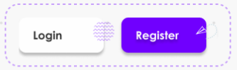

**Buttons:**

**Login Button:** In the top right corner, the "Login" button features a white background and employs a clear, legible font. Its design ensures easy noticeability without overshadowing primary content. Interactive cues, such as subtle colour changes or animations upon hover, indicate its functionality.

**Register Button:** Adjacent to the "Login" button, the "Register" button stands out with a distinctive purple background. This colour adds vibrancy and effectively draws user attention, encouraging engagement. The text is presented in white for high readability against the purple backdrop.

**Login Page**

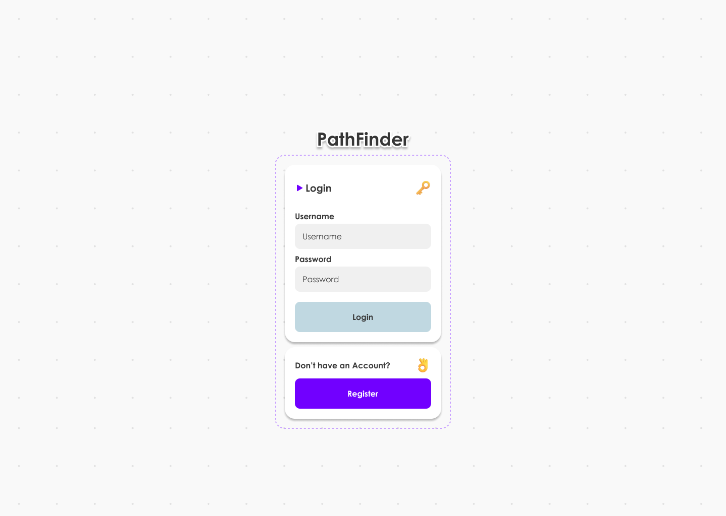

**Background:**

The Login Page design features a clean and minimalist aesthetic with a white background. This choice creates a sense of simplicity and enhances readability.

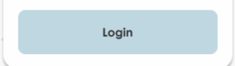

**Button:**

The Login button, central to this page, is designed with a subtle and professional grey colour. The grey hue lends a sense of sophistication and neutrality to the button, aligning with a minimalist design approach. The text on the button, typically "Login" or a similar label, is displayed in a contrasting colour for high visibility and legibility.

**Layout:**

The layout of the Login Page is straightforward and uncluttered, aligning with a minimalist design philosophy. It provides a clear and focused user experience, with the central login button as the primary call to action. This design prioritizes simplicity and a user-focused approach, with a white background and a subtle grey login button, providing a clean and professional login experience.

**Registration Page**

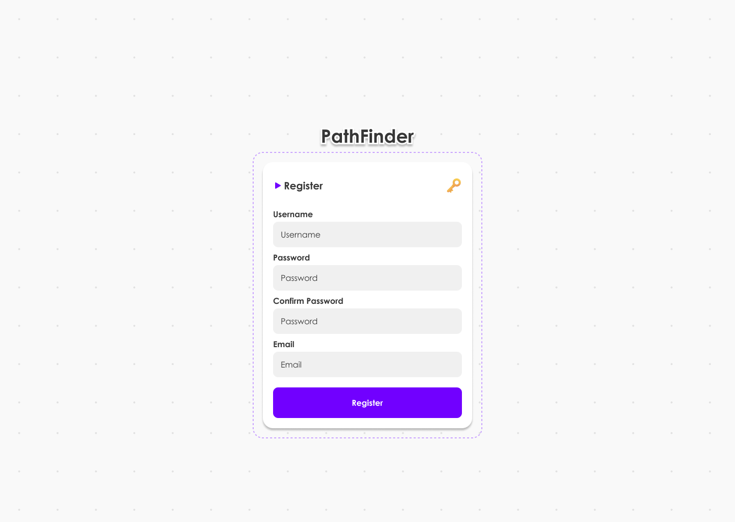

**Background:**

The Registration Page design maintains a clean and minimalist aesthetic with a white background. This choice creates a sense of simplicity and enhances readability, contributing to an uncluttered and user-friendly interface.

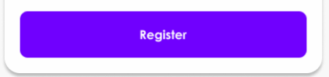

**Button:**

The "Register" button, central to this page, is highlighted with a striking purple colour. The purple colour adds a touch of vibrancy and draws attention to the registration action, making it visually prominent on the page. The text on the button, typically "Register" or a similar label, is displayed in a contrasting colour for high visibility and readability.

**Layout:**

The layout of the Registration Page is straightforward and focused, adhering to minimalist design principles. It centres the user's attention on the registration button, making it the key element of the page. This design emphasizes simplicity and user-friendliness, with a white background and a vibrant purple "Register" button, offering a clean and visually appealing registration experience.

**Generate Page 1**

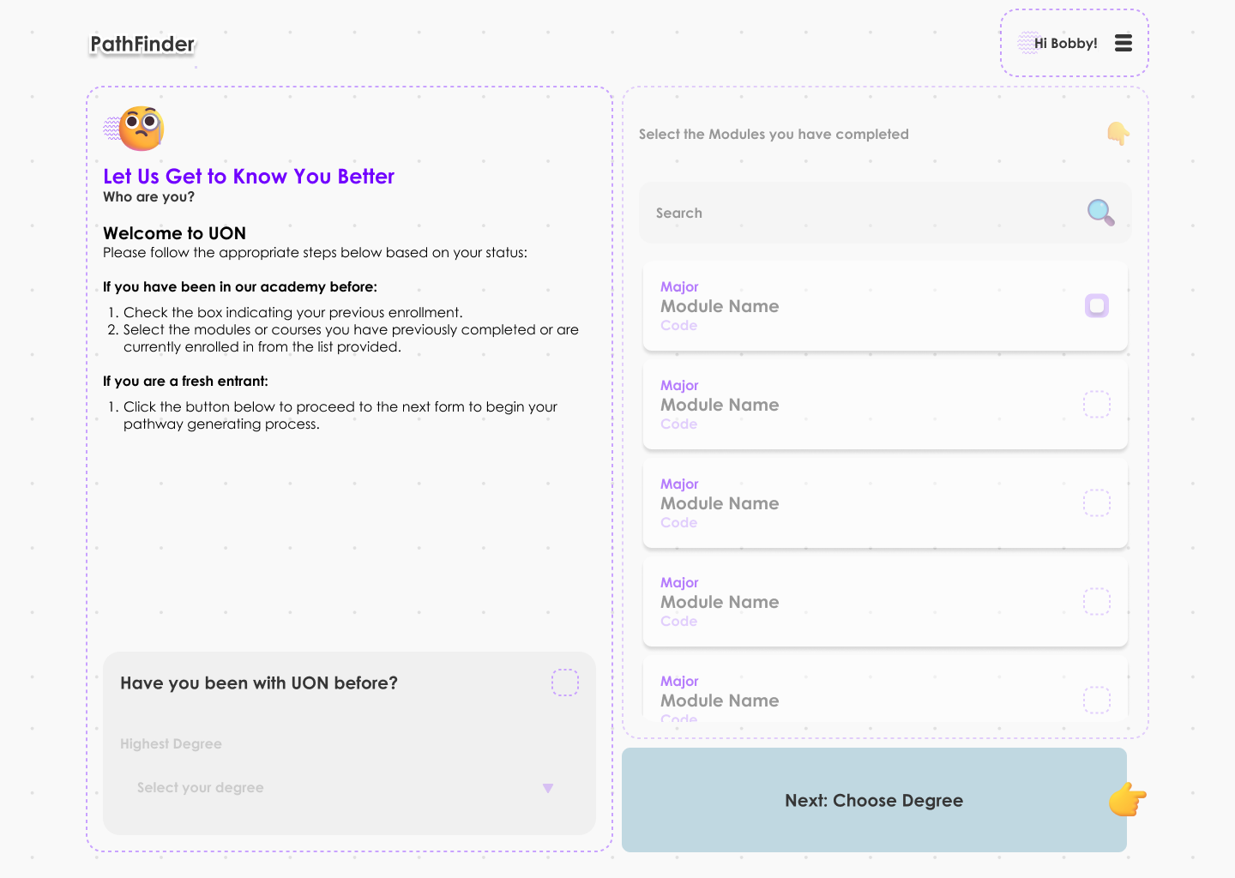

**Background:**

The page features a clean white background, creating a sense of simplicity and a fresh, welcoming atmosphere.

**Left Column:**

On the left side of the page, a column titled "Let Us Get to Know You Better" is prominently displayed. It serves as a welcoming introduction to the user, setting a friendly and engaging tone for the interaction.

Just below the welcoming message, there is a checkbox option with the text "Have you been with UON before?" Users can easily indicate whether they have prior experience with the institution.

**Right Side:**

On the right side of the page, users have the option to select the module(s) they have completed before. This selection can be presented as a list of available modules or courses.

**Right Bottom:**

Positioned at the right bottom corner of the page is a clearly visible "Next" button. The button stands out for easy access and indicates the next step in the process.

**Overall Layout:**

The page maintains a balanced and user-friendly layout, ensuring that users can easily engage with the content. The left column offers a welcoming introduction and a checkbox to capture user information. The right side is dedicated to module selection, and the "Next" button is strategically placed for a seamless transition to the next step in the process. This design emphasizes user engagement and a straightforward layout, providing a welcoming and efficient experience for users as they progress through the registration process on the UON platform.

**Generate Page 2**

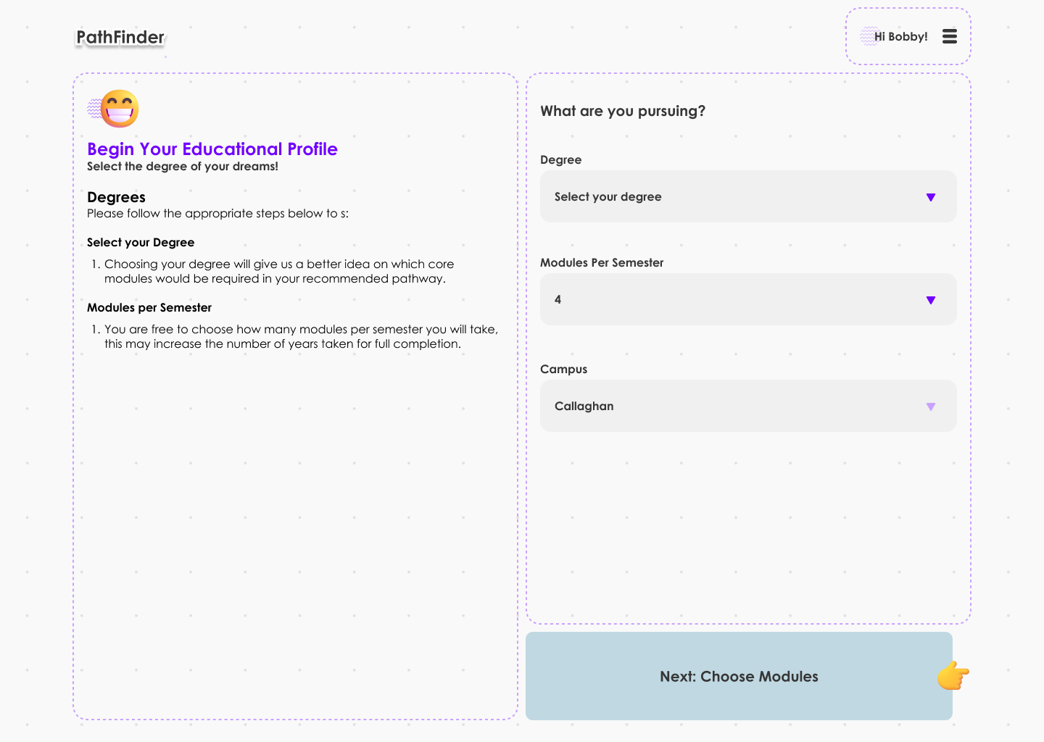

**Background:**

The page maintains a clean white background, creating a sense of simplicity and a welcoming atmosphere.

**Right Column:**

The right column is updated to capture information about what the user is pursuing. It includes the following sections:  
- Select Your Degree: Users can choose their intended degree or program from a list of available options.  
- Modules for Semester: Users can select the specific modules or courses they plan to take for the upcoming semester. This could be presented as a list with checkboxes.  
- Campus: Users can specify their preferred campus or location.

**Right Bottom:**

At the right bottom corner of the page, there is a prominent "Next" button for users to proceed to the next step in the registration process.

**Overall Layout:**

The layout maintains a user-friendly design, with the left column focusing on the introductory message and gathering user information, and the updated right column allowing users to specify their degree, module choices, and campus preferences. This design ensures a consistent and welcoming user experience, providing users with a clear and efficient way to input their information and preferences during the registration process on the UON platform.  
  
**Generate Page 3**

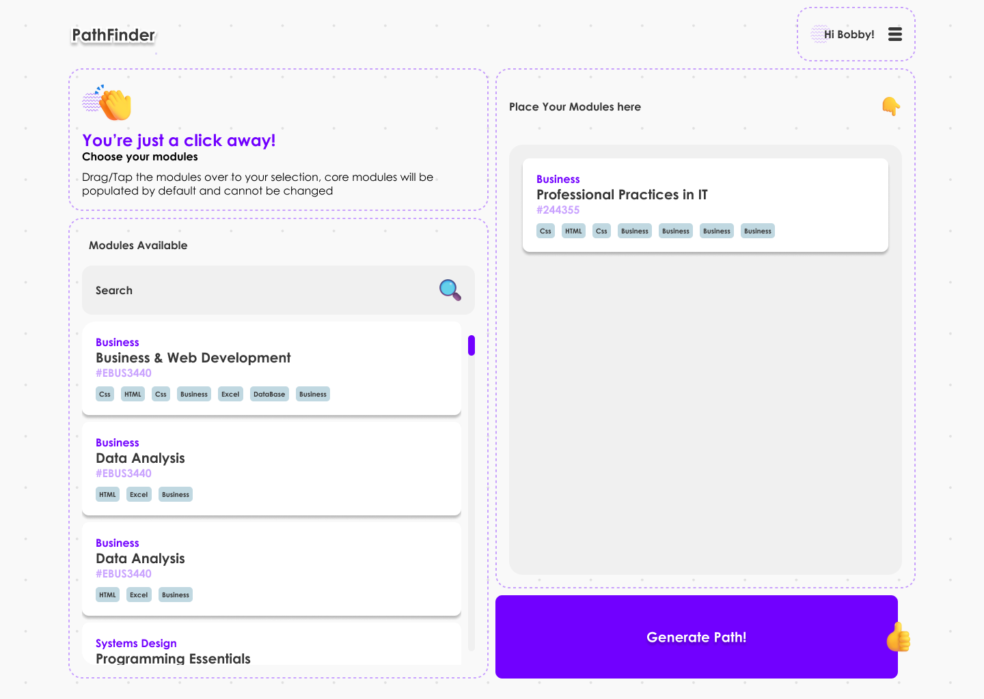

**Background:**

The page maintains a clean white background, creating a sense of simplicity and a user-friendly environment.

**Left Column: Available Modules**

The left column of the page is dedicated to displaying a list of available modules or courses. These modules are presented as a list, and users can easily browse through them.

**Right Column: Place Your Modules**

The right column is designed to allow users to interact with the available modules. Users can drag and drop the modules they want to take from the left column into the right column. This drag-and-drop interaction offers a user-friendly and intuitive way to customize their module selections.

**Right Bottom: Generate Path Button**

At the right bottom corner of the page, there's a "Generate Path" button. Initially, this button is greyed out and not clickable. However, it becomes clickable and active once users have dragged at least one module to the right column.

**Interaction:**

Users can simply click and hold a module in the left column and drag it to the right column to select their preferred modules. The "Generate Path" button encourages users to act once they've made their selections.

**Overall Layout:**

The layout is designed to be user-centric, allowing users to easily explore and customize their module choices. The drag-and-drop feature simplifies the process of module selection, and the "Generate Path" button ensures that users can proceed once they've finalized their choices. This design provides a straightforward and engaging user experience, allowing users to select the modules they want and generate their academic path by simply dragging and dropping their choices.

**Pathway Dashboard**

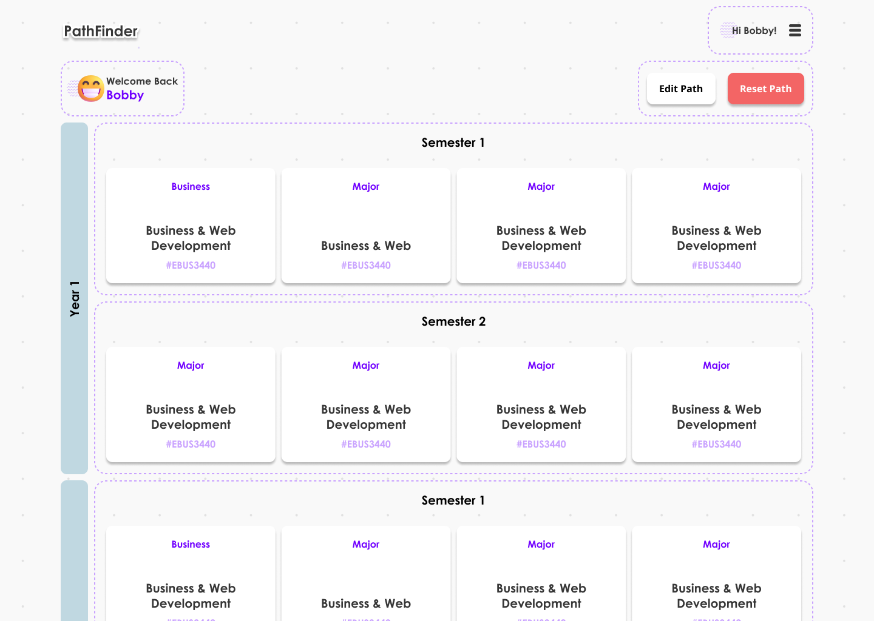

**Background:**

The Pathway Dashboard features a clean white background, contributing to a clear and professional look.

**Pathway Display:**

The central focus of the page is on the generated pathway, which visually shows the user what to expect in each semester and year. This pathway can be presented as a structured list or timeline, with clear descriptions of the courses or events planned for each semester.

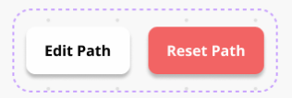

**Buttons (Right Top):**

In the right top corner, there are two prominent buttons:

Edit Path (White Button): The "Edit Path" button, in white, provides users with the option to customize or make changes to their generated pathway. It allows them to adjust their course selections or make modifications to their academic plan.

Reset Path (Red Button): The "Reset Path" button, in a noticeable red colour, offers users the ability to reset their pathway to its default state. This can be used if they want to start over or undo all changes made.

**Interaction:**

Users can click the "Edit Path" button to access editing options and make changes to their pathway. The "Reset Path" button, while clickable, might prompt a confirmation dialog to ensure users do not accidentally reset their path.

**Overall Layout:**

The layout is user-centric, with a clear presentation of the pathway, allowing users to understand their academic journey briefly. The buttons for editing and resetting the path are conveniently placed for user interaction. This design aims to provide users with a clear and visually appealing representation of their academic pathway while offering flexibility to adjust as needed.

**Pathway Dashboard Editing**

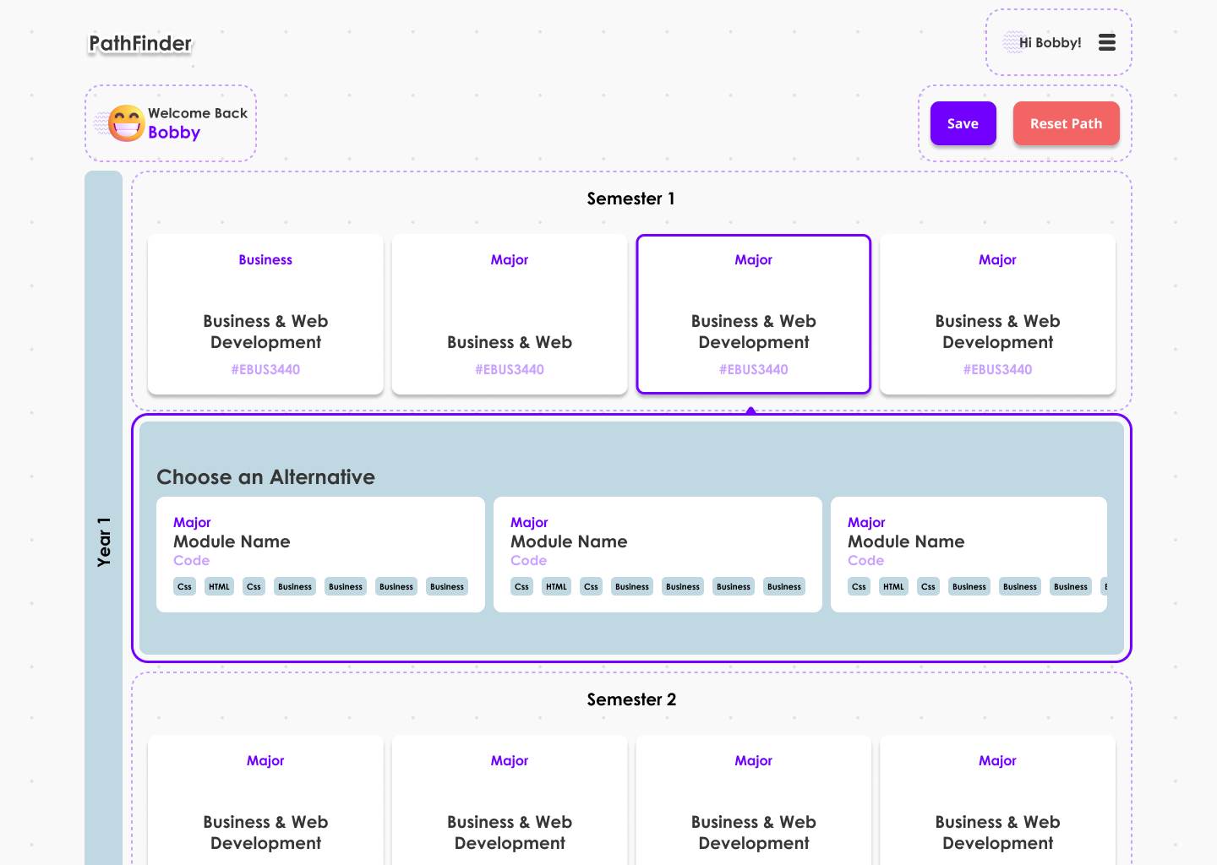

**Colours:**

The colours blue and red were chosen for background of the text and “Register” buttons because they stand out and work as a highlighter to draw users to focus on those areas. The mainly white background gives a clean and professional look. There is a grey background for the “year” and “alternative” sections to provide a clean separation.

**Layout:**

The top left shows the name/logo of our website.

Below it shows the name of your account.

The top right is your account menu dropdown.

Below it has the “save” and “reset path” buttons.

The rest of the page consists of your different modules under each semester, with an alternative path section in between each semester.

**Specific UI:**

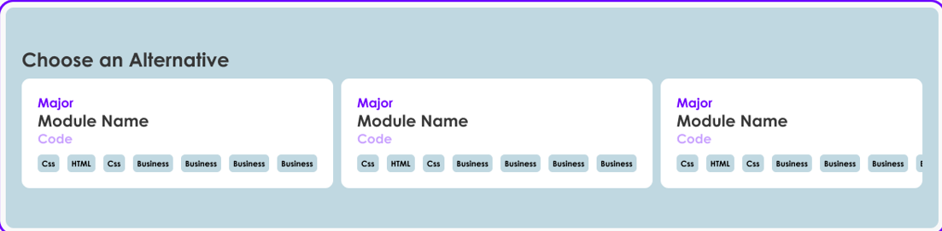

This “alternative path” section only appears in your editing dashboard before you can continue to the module selection of your upcoming semester. Your upcoming module selections will be fully determined by which pathway you select in this section.

**FINAL INTERFACE: CMS**

**Admin Login**

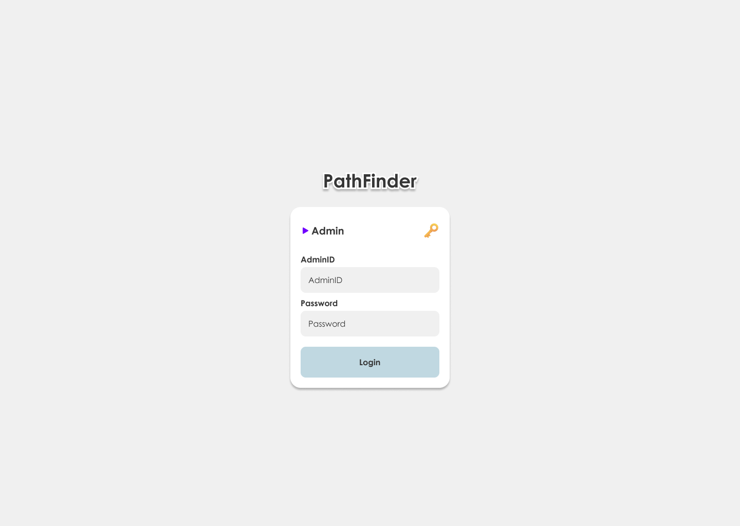

**Background and Colours:**

The page features a clean white background, creating a sense of simplicity and a fresh, for the admin.

**Layouts:**

The layout of the admin login panel follows the user end login panel to keep the interface standardised.

**Edit Courses**

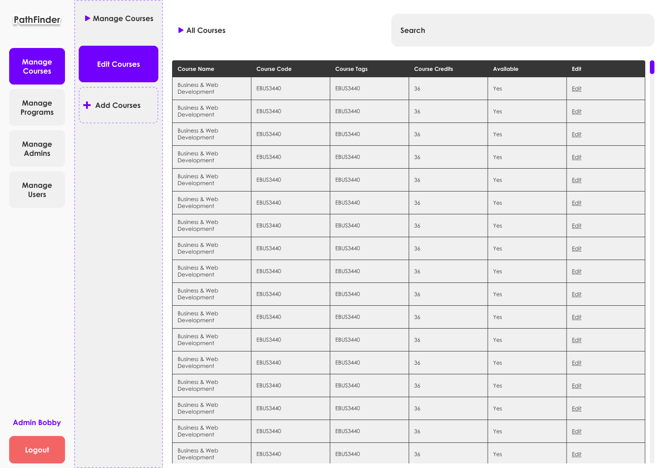

**Background and Colour:**

The background and colour of CMS is made to look simple and clean for the admin’s use to avoid unnecessary UI attention. The CMS is taken reference from universal CMS interfaces.

**Design and Layout:**

The main menu panel is the most left panel, highlighted in purple. The second column panel is a flyout of the selected button “Manage Courses”

**Add Courses**

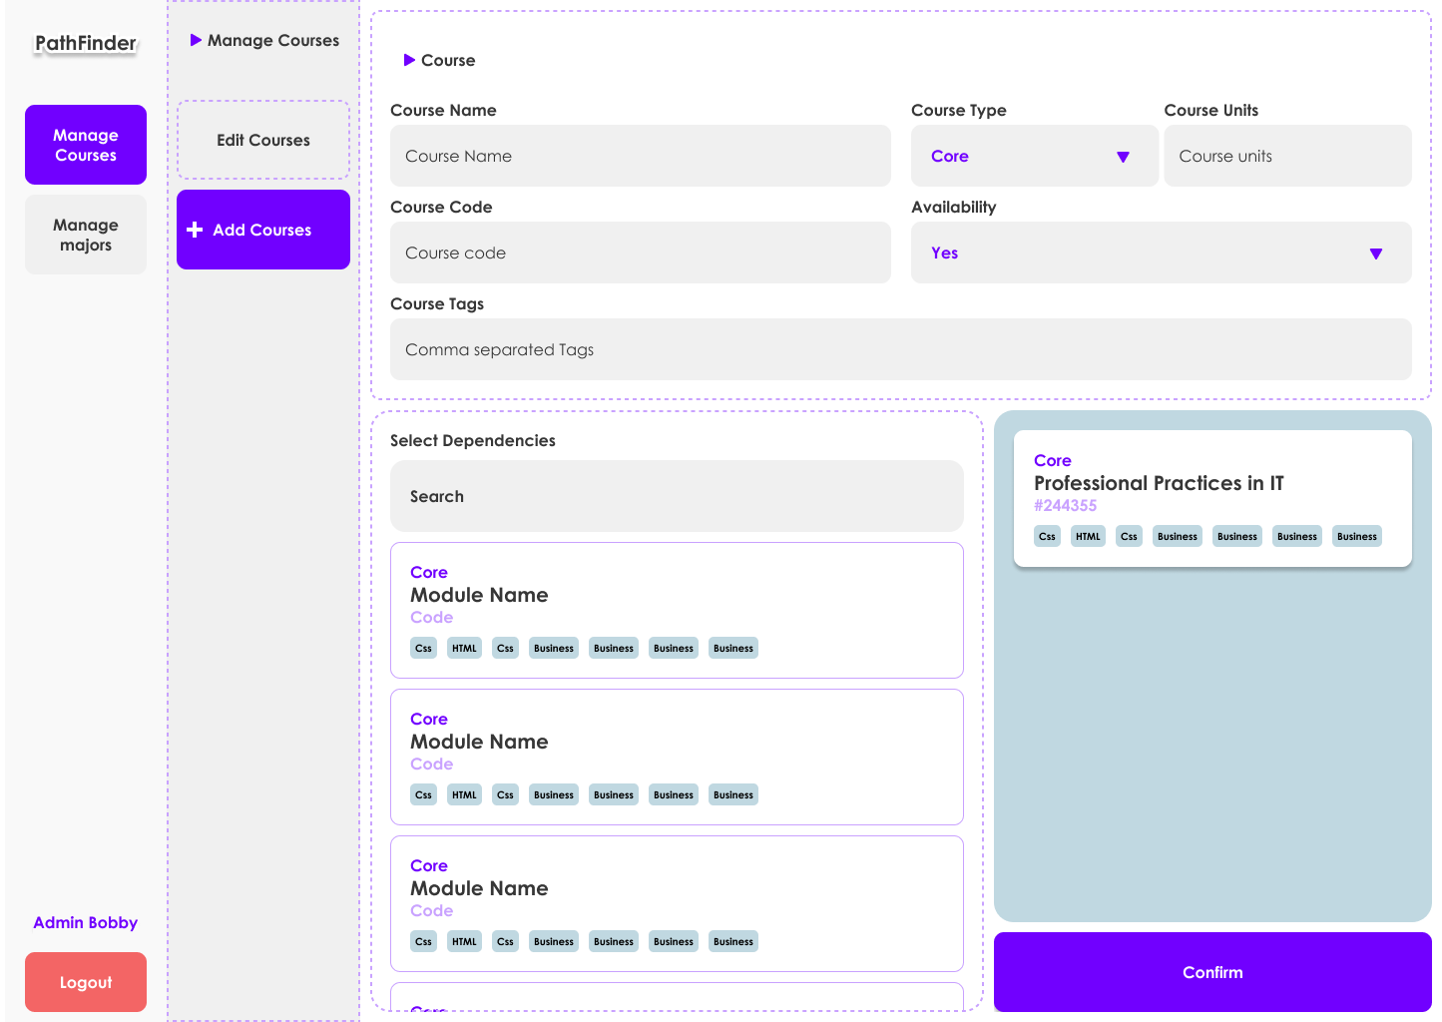

**Background and colour:** The background and colour of this CMS is made to look simple and clear for the admin to see clearly and edit faster. **Design and Layout**: The layout of the Courses detail is on top of the page and highlighted with purple. The Confirm button is at the bottom right of the page and is highlighted with purple.For the logout button is at the bottom left of the page and highlighted with red colour to see clearly.

**Edit Admin**

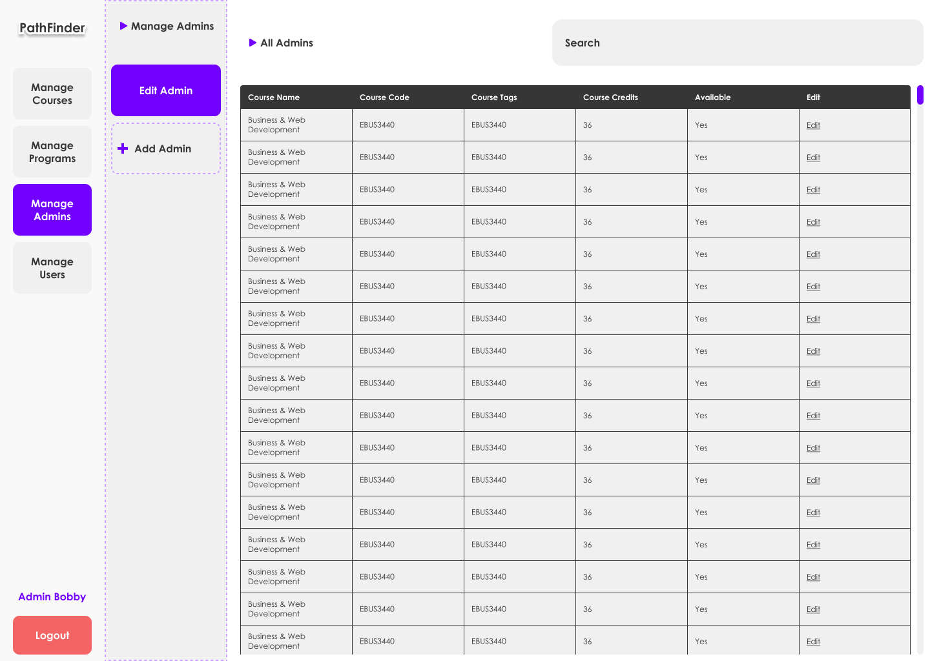

**Background and Colour:**

The background and colour of CMS is made to look simple and clean for the admin’s use to avoid unnecessary UI attention. The CMS is taken reference from universal CMS interfaces.

**Design and Layout:**

The main menu panel is the most left panel, highlighted in purple. The second column panel is a flyout of the selected button “Manage Admin”

**Add Admin**

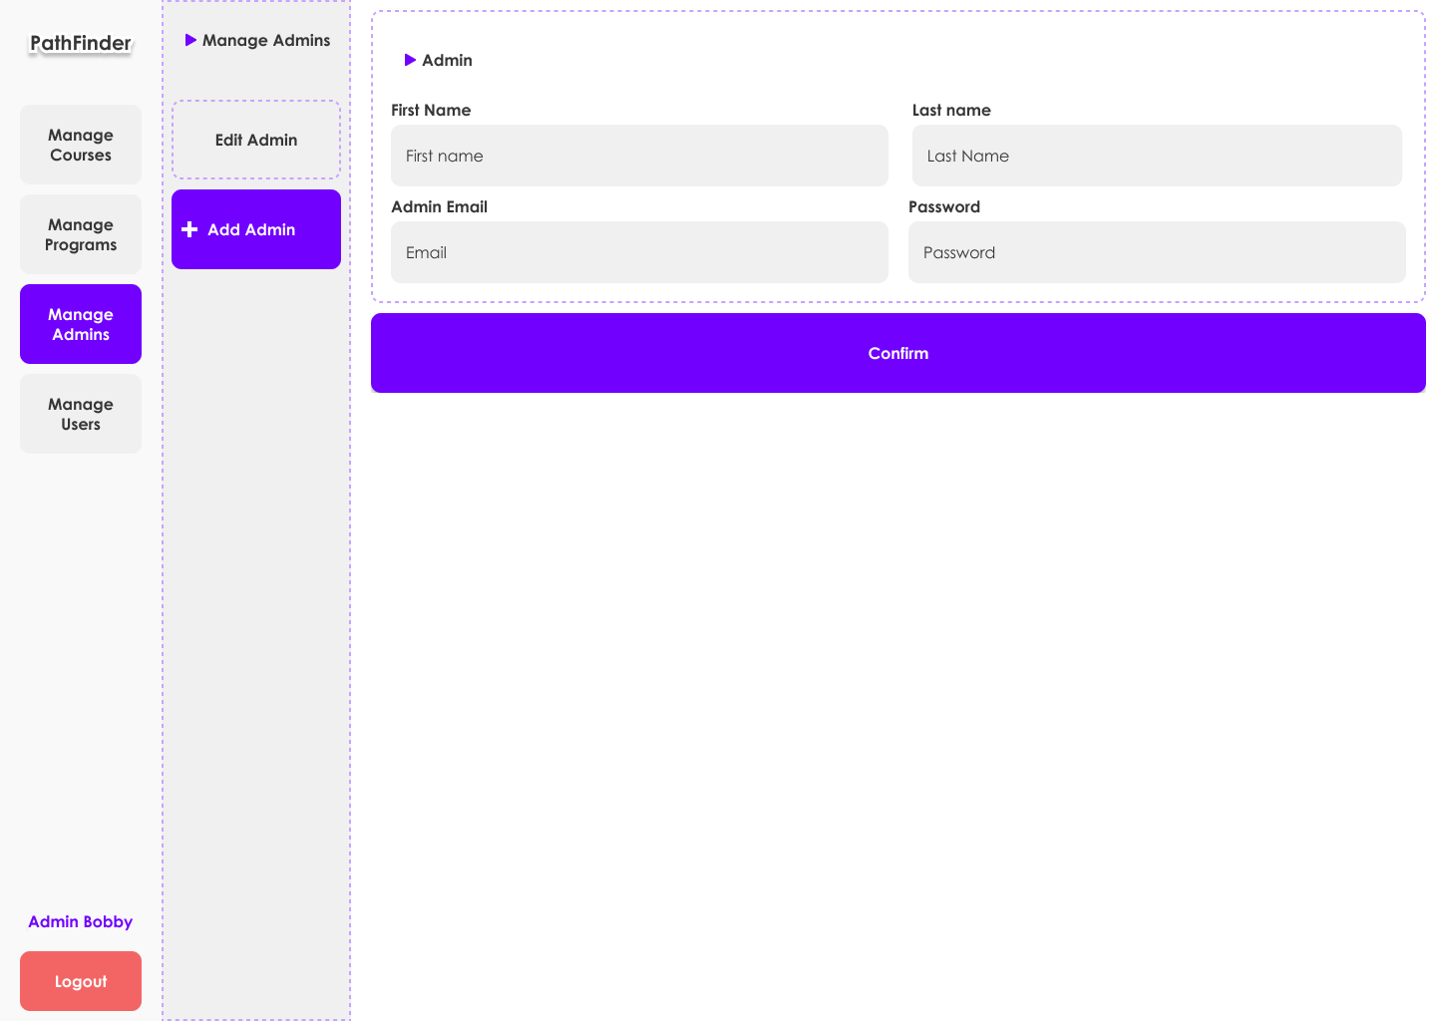

**Background and Colour:**

The background and colour of CMS is made the admin to look more clearly and simply to fill out their details.

**Design and Layout:**

The main menu panel is the most left panel, highlighted in purple. The second column panel is a flyout of the selected button “Manage Admins.” The confirmation button also is highlighted in with purple.